

DromGrader

USC Housing Mobile Application Project
ISE515 Engineering Project Management
Professor Herag Haleblian
Team 4

Diya Jigneshbhai Shah Guozheng Yang Mihir Kavishwar Rhythm Deo Sami Andari

Table of Contents

Table of Contents 1
Project Initiation & Planning 1
Board of Directors & Project Sponsor meeting 1
Attendees 2
Agenda 2
Meeting Summary 3
Project Charter 3
Work Breakdown Structure (WBS) 15
Resource Plan 21
Project Organization 26
Project Schedule 29
Risk Plan 33
Project Budget, Implementation & Presentation 37
Project Budget (Sami Andari, Mihir Kavishwar) 37
Project Assumptions 42
Organizational Change Management Plan
Introduction 46
Project Change Controls 65

Project Initiation & Planning

Board of Directors & Project Sponsor meeting

Meeting Recap Board of Directors & Project Sponsor Meeting
Date: October 17, 2023
Time: 4:10 PM

Attendees

Board of Directors
- Diya Shah
- Guozheng Yang
- Mihir Kavishwar
- Rhythm Deo
- Sami Andari

Project Sponsor
- Professor Herag Haleblian

Agenda
- Welcome and Introduction
- Project Overview Explanation and Purpose
- Clarification on Scope of Project
  - Specific Technological Platforms
  - Security Measures
  - Data and Feature Inclusions
  - Success Metrics
- Estimated Budget and Time Frame
- Feedback Session Inputs from Board Members
- Closing Remarks

Meeting Summary
The October 17, 2023 Board of Directors/Project Sponsor Meeting was conducted with a structured approach to address the upcoming project's scope and relevant details. Professor Herag Haleblian, our esteemed Project Sponsor, provided a comprehensive project overview, emphasizing its significance within our academic journey.

Technological Platforms
The board sought clarity on platform preferences, and Professor Herag affirmed the flexibility to select platforms that align with project objectives.

Security Measures
Queries regarding stringent security guidelines were answered with a reassurance of our autonomy in determining security measures.

Data and Features
Specific inclusions were discussed, with Professor Herag encouraging creativity and flexibility in our approach.

Budget and Time Frame
The meeting delved into estimated budget requirements and the establishment of a realistic timeline. Professor Herag assured his support in achieving our project's success.
Throughout the meeting, Professor Herag stressed the importance of adaptability and flexibility in shaping the project to meet our educational needs. In closing, he reiterated his commitment to supporting our learning experience and the project's success, recognizing our autonomy in decision-making.

Project Charter

General Project Information
Project Title | USC Housing Mobile Application DormGrader | Executive Sponsor | University of Southern California
Project Start Date | November 6th, 2023 | Department Sponsor | Herag Haleblian
Project End Date | September 23rd, 2024 | Project Status | Project Plan Proposed

Project Team
Project Manager | Mihir Kavishwar
Project Team | Rhythm Deo
Project Team | Sami Andari
Project Team | Diya Shah
Project Team | Gouzheng Yang

Stakeholders
USC Board of Directors
USC Students and Staff
USC IT Department
Project Development Team
Marketing Team
Landlords in the Area
Advertised Businesses
Potential Investors or Funders
User Feedback Community
Competing Platforms
Regulatory Authorities
Campus Safety and Security

Business Justification
- USC students face ongoing housing challenges, including limited unbiased housing feedback and difficulties in finding compatible roommates and managing used items.
- The project focuses on a mobile app to address these issues, with a key feature being genuine peer reviews to empower students and encourage better landlord practices.

- The project's objectives are to save students time, enhance their housing experience, and address these challenges.
- Specific objectives include improving housing searches with reliable reviews, roommate matching, and a used goods marketplace.

- The project also aims for financial self-sufficiency through integrated advertising.

Project Scope

In Scope
- Development of a mobile application for both iOS and Android platforms, encompassing three key sections: Housing Reviews, Roommate Matcher, and Buying/Selling Goods.

- Creation of a web platform that is seamlessly compatible with the mobile application, ensuring a unified user experience.

- Implementation of a secure student login system using USC ID, with automatic synchronization to streamline user registration and authentication.

- Integration of an advertisement platform to generate revenue while maintaining user experience integrity.
- Establishment of a direct communication channel via email for inquiries or user complaints.

- Provision for users to include images when listing furniture for sale, enhancing the quality of listings.

- Creation of generic user profiles for students to facilitate roommate matching, helping users find compatible living arrangements based on shared preferences and requirements.
- Basic search and filtering options for users to find housing, roommates, and items for sale.
- User notifications for key events, such as matches found or new listings.

- User account management features for updating profiles and preferences.

- Reporting functionality for inappropriate or fraudulent listings and users.

Out Scope
- Exclusion of features related to transportation, carpooling, or parking services, as these functionalities do not align with the application's core purpose.
- No integration with institutions or systems outside of USC, as the application's primary focus is to serve the USC student community exclusively.

- No incorporation of a chatbot system for handling complaints, as this is beyond the intended scope.

- Exemption from processing financial transactions within the application.

- Omission of features unrelated to the main purpose, such as food delivery or ordering services.
- Avoidance of becoming a full-fledged social media platform, keeping the primary focus on housing and roommate solutions.
- No provision for hosting or managing non-furniture items for sale within the application.

- Exclusion of responsibilities related to the creation of promotional or marketing materials for advertisers.
- Non-engagement in handling non-academic or non-housing-related disputes, which are beyond the defined scope.

Project Success Criteria
- Design the application to accommodate future growth and a user base of at least 5,000 students within the first year.
- Aim for an average user session duration of 5 minutes or more to encourage active user engagement.

- Maintain a user retention rate of at least 60% after the first six months.

- Target an average response time of less than 2 seconds for key interactions to ensure a responsive user experience.
- Ensure compliance with data privacy regulations and conduct security audits for 100% data security.
- Meet Web Content Accessibility Guidelines (WCAG) standards for inclusivity, especially for users with disabilities.

- Implement marketing strategies to achieve a 5% increase in downloads and registrations every quarter during the first year.
- Address technical issues within 24 hours and release regular updates every quarter to enhance user experience and security.

Project Deliverables
Initial Phase:
- Develop a user-friendly mobile application for both iOS and Android platforms, featuring three key sections: Housing Reviews, Roommate Matcher, and Buying/Selling Goods, with a focus on intuitive cross-platform functionality.

- Create a seamlessly integrated web platform which ensures a unified user experience across devices.

- Implement a secure USC ID-based login system for user convenience and data accuracy.

- Strategically integrate an advertisement platform to generate revenue while preserving a smooth user experience.
- Offer timely user notifications for matches and new listings, keeping users informed.

- Provide a direct communication channel via email for inquiries and user support, ensuring timely issue resolution.

Housing Reviews Section:

- Maintain a robust rating system for accountability and the authenticity of reviews, prioritizing user trust.

- Enable users to filter housing options based on location, price range, and amenities, tailoring their search.

- Regularly update information and expand data on housing areas for accuracy.

Roommate Matcher Section:
- Create user profiles for students to share roommate preferences and expectations, enhancing compatibility.

- Develop a matching mechanism to pair students with compatible profiles and encourage direct communication via USC email.

- Implement user-friendly search and filtering options for easy discovery of housing, roommates, and items for sale.

- Provide user account management features for profile customization and preferences.

Buying/Selling Goods Section:
- Enable users to post items for sale with images, descriptions, and prices, simplifying the listing process.

- Facilitate the buying and selling of furniture among USC students, fostering a convenient marketplace within the university community.

Security and Privacy:

- Ensure the security and confidentiality of user data through robust data protection and encryption techniques.

- Strictly adhere to university data privacy policies, complying with regulatory standards.

- Implement a secure login process for identity validation.

- Develop reporting functionality for users to report inappropriate or fraudulent listings and users, maintaining platform integrity and safety.

Project Challenges
- Ensuring data security, especially for USC student IDs and personal information.

- Efficiently managing server traffic during peak-demand periods for a responsive user experience.
- Maintaining transparency and impartiality in housing reviews for accurate and trustworthy information.

- Creating an inclusive, non-discriminatory environment for roommate matching, promoting a safe and respectful community.

- Implementing strong measures to prevent online fraud and protect users in buying and selling goods.
- Balancing revenue generation with user satisfaction for a sustainable income stream.

- Regularly updating and upgrading data to accommodate new students every semester, ensuring accuracy and relevance.

Project Alternatives
- Create a web platform without a mobile application.
- Develop a mobile application for either iOS or Android, instead of both platforms.

- Explore partnerships with external institutions or systems beyond USC to enhance the application's functionality and user base.

- Include the capability for users to process financial transactions within the application.
- Expand the platform to include non-furniture items for sale.
- Take on responsibilities for creating promotional and marketing materials for advertisers.

Project Milestones
Project Initiation | December 5th, 2023
Planning Phase | March 20th, 2024
Development Phase | May 4th, 2024
Testing Phase | July 24th, 2024
Marketing and Roll Out Phase | August 30th, 2024
Project Closure | September 23rd, 2024

Known Project Risks
- Data breaches due to security weaknesses or employee errors.
- Biased housing reviews influenced by students or agents.
- Low user adoption and acceptance of the software.
- Privacy and security breaches, leading to unauthorized access or exposure.
- Competition from other apps and options.
- Technical challenges causing project delays.
- Improper communication and misunderstandings within different teams.

- Legal issues, including copyright infringement, data privacy breaches, and regulatory non- compliance.

- Budget overruns, where the project budget exceeds projections.

- Financial sustainability challenges, including insufficient revenue generation or market performance issues.

Project Constraint
- The project is constrained by a predetermined budget of approximately $800,000, which affects financial resource allocation.
- Fixed start and end dates (November 6th, 2023, to September 23rd, 2024) impose schedule limitations.

- The project team is limited to assigned members, including the project manager and team, affecting resource availability.
- Resource availability, particularly technology and development resources, is constrained.
- User adoption expectations, like reaching a user base of 5,000 students, must be met for project success.
- Adherence to data privacy regulations and 100% data security compliance is a binding constraint.
- Technical issues must be resolved within a 24-hour timeframe.
- Meeting marketing strategy targets for a 5% increase in downloads and registrations every quarter is essential for success.

Project Budget
Personnel: $250,000
- Salaries for project manager and team members.
- Consultants or experts as needed.
Technology and Development: $150,000
- Mobile application development for iOS and Android.
- Web platform development.
- Secure USC ID-based login system implementation.
- Advertisement platform integration.
User Notifications and Communication: $25,000
- Email communication channel setup.
- User support and inquiry management.
Housing Reviews Section: $75,000
- Rating system implementation.
- Filter options for location, price range, and amenities.
- Data updates and expansion.
Roommate Matcher Section: $75,000
- User profiles creation.
- Matching mechanism development.
- Search and filtering options.
- User account management features.
Buying/Selling Goods Section: $25,000
- Item listing features.
- Facilitating buying and selling of furniture.

Security and Privacy: $100,000
- Data security measures and encryption.
- Compliance with data privacy policies.
- Secure login process.
- Reporting functionality.
Marketing: $75,000
- Marketing strategies, campaigns, and user acquisition incentives.
- Promotion of the application.
- Monitoring user engagement.
Legal and Compliance: $25,000
- Legal consultation for compliance.
- Content moderation.
- Terms of service establishment.
Infrastructure and Maintenance: $20,000
- Server infrastructure and maintenance.
Contingency: $5,000
- Reserved for unforeseen issues or additional requirements.
Revised Total Budget: $800,000

Project Sponsor Acceptance
Signature of Project Sponsor |  | Date

Work Breakdown Structure (WBS)
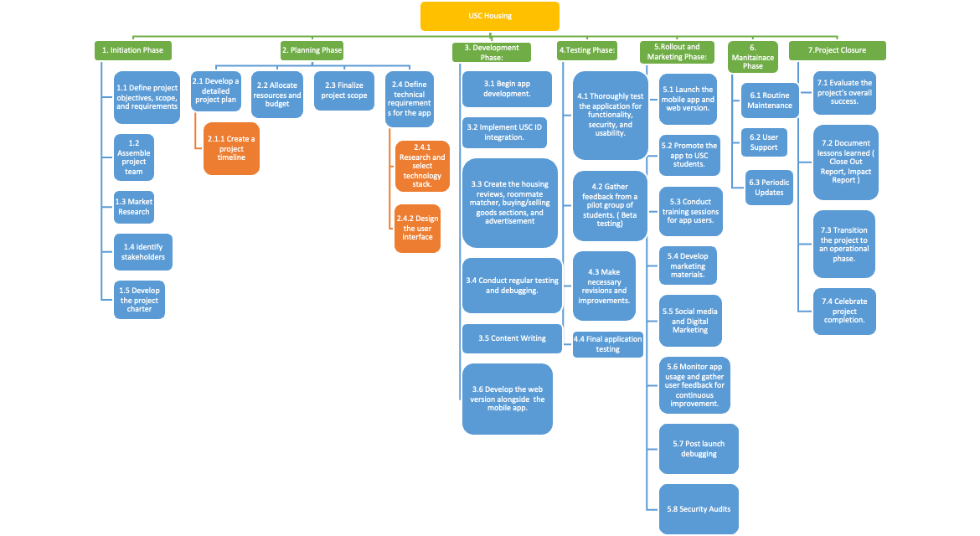

Code no | Phase | Task Name | Description | Start | Finish | Critical path
1.1 | Initiation | Define project objectives, scope, and requirements | Set the main objectives and boundaries | Mon 10/30/23 | Fri 11/10/23 | No
1.2 | Initiation | Assemble project team | Formulate the necessary team | Mon 11/13/23 | Fri 11/24/23 | No
1.3 | Initiation | Market Research | Understand market needs and competition | Mon 11/13/23 | Fri 11/17/23 | No
1.4 | Initiation | Identify stakeholders | Recognize key parties involved in the project | Mon 11/13/23 | Fri 11/17/23 | No
1.5 | Initiation | Develop the project charter | Draft a formal project directive | Mon 11/27/23 | Tue 12/5/23 | Yes
2.1 | Planning | Develop a detailed project plan | Formulate a comprehensive plan | Wed 12/6/23 | Thu 12/7/23 | Yes
2.1.1 | Planning | Create a project timeline | Schedule milestones and tasks | Fri 12/8/23 | Thu 12/14/23 | No
2.2 | Planning | Allocate resources and budget | Assign resources and set budget | Wed 12/6/23 | Tue 12/19/23 | No
2.3 | Planning | Finalize project scope | Confirm the boundaries and deliverables | Wed 12/20/23 | Tue 1/2/24 | No
2.4 | Planning | Define technical requirements for the app | Specify tech needs and constraints | Wed 1/3/24 | Tue 1/9/24 | No
2.4.1 | Planning | Research and select technology stack | Choose the appropriate tech tools | Wed 1/10/24 | Tue 1/23/24 | No
2.4.2 | Planning | Design the user interface | Craft the UI for the app | Wed 1/24/24 | Tue 2/20/24 | No
3.1 | Development | Begin app development | Start building the app | Wed 2/21/24 | Wed 2/21/24 | No
3.2 | Development | Implement USC ID integration | Integrate university ID system | Thu 2/22/24 | Fri 3/1/24 | No

3.3 | Development | Create the housing reviews, roommate matcher, buying/selling goods sections, and advertisement | Develop core features | Thu 2/22/24 | Wed 3/13/24 | No
3.4 | Development | Conduct regular testing and debugging | Ensure app quality and functionality | Thu 3/14/24 | Wed 3/20/24 | No
3.5 | Development | Content Writing | Generate content for the app | Thu 2/22/24 | Mon 3/4/24 | No
3.6 | Development | Develop the web version alongside the mobile app | Parallel development of mobile and web versions | Wed 2/21/24 | Tue 3/5/24 | No
4.1 | Testing | Thoroughly test the application for functionality, security, and usability (Alpha test) | Comprehensive testing phase | Thu  3/21/24 | Wed  5/1/24 | No
4.2 | Testing | Gather feedback from a pilot group of students (Beta testing) | Collect and analyze user feedback | Thu  5/2/24 | Wed  6/12/24 | Yes
4.3 | Testing | Incorporate feedback and make necessary changes | Update the app based on user feedback | Thu  3/21/24 | Wed  4/3/24 | No
4.4 | Testing | Final application testing | Perform a last round of comprehensive testing | Thu  6/13/24 | Mon  7/8/24 | No

5.1 | Rollout and Marketing Phase | Launch mobile and web version | Release the application to the public | Tue 7/9/24 | Tue 7/9/24 | Yes
5.2 | Rollout and Marketing Phase | Promote the app to USC | Marketing and promotion activities | Wed 7/10/24 | Fri 7/19/24 | No
5.3 | Rollout and Marketing Phase | Conduct training sessions for app users. | Sessions and workshops for users on how to use the app | Wed 7/10/24 | Fri 7/19/24 | No
5.4 | Rollout and Marketing Phase | Marketing Campaigns | Launch marketing campaigns to attract more users | Tue 7/9/24 | Fri 7/12/24 | No
5.5 | Rollout and Marketing Phase | Social Media and Digital Marketing | Make a social presence for the app | Mon 7/22/24 | Fri 8/9/24 | No
5.6 | Rollout and Marketing Phase | User Feedback Collection | Collect feedback from the initial users for improvements | Wed 7/10/24 | Wed 7/31/24 | No
5.7 | Rollout and Marketing Phase | Post Launch Debugging | Any app related debugging that is required | Thu 8/1/24 | Wed 8/7/24
5.8 | Rollout and Marketing Phase | App Updates | Implement feedback-based updates to the application | Thu 8/1/24 | Wed 8/14/24 | No

6.1 | Maintenance Phase | Routine Maintenance | Regular checks and updates for the application | From launch | Ongoing | No
6.2 | Maintenance Phase | User Support | Provide support to the users facing any issues | From launch | Ongoing | No
6.3 | Maintenance Phase | Periodic Updates | Release updates based on new features or improvements | Varies | Varies | Depends on update significance
7.1 | Project Closure Phase | Evaluate the project's overall success | Determining how well the project met its objectives and overall goals | Thu 8/15/24 | Wed 8/21/24 | No
7.2 | Project Closure Phase | Document lessons learned & Close Out Report, Impact Report | Compilation of experiences, learnings, and feedback for future reference | Thu 8/22/24 | FWed 9/4/24 | No
7.3 | Project Closure Phase | Transition the project to an operational phase | Shifting the project from development to day-to-day operations | Thu 8/15/24 | Tue 8/27/24 | No
7.4 | Project Closure Phase | Celebrate project completion | Commemorating the team's hard work and the project's success | Thu 9/5/24 | Thu 9/5/24 | No

Resource Plan

1. Personnel
Sr. no | Role | Description | Quantity | Duration
1.1 | Project Manager | Oversees the project, ensuring it stays on schedule, budget, and meets the project objectives | 1 | Full project duration
1.1.1 | PM Team | Assists the PM | 1 | Full project duration
1.2 | UI/UX Designers | Design the user interface and user experience for the mobile and web  platforms. | 2 | Up to Design completion
1.3 | Backend Developer | Handles server-side logic, database management, and  API development. | 2 | Up to Deployment
1.4 | Frontend Developer | Develops the user interface for both mobile apps and the web platform | 2 | Up to Deployment
1.5 | QA Tester | Ensures the product is bug-free by conducting various tests | 1 | Development completion to Deployment
1.6 | Support team | Handles user registration, data management, and  user support | 1 | After Project Deployment
1.7 | Marketing Personnel | Handles promotion, advertisement, and outreach for the app. | 2 | From Development to completion life cycle of the app
1.8 | Content Moderator | To ensure unbiased and appropriate content, content moderators will review and approve reviews, listings, and  user-generated content. | 1 | From Development completion to life cycle of the app

1.9 | Financial Analysts | Experts in finance will monitor income sources, such as advertisements, to ensure the application's financial self-sufficiency. | 1 | Development completion to Deployment
1.1 | Legal advisors | Legal experts will ensure compliance with relevant  regulations and privacy standards. | 1 | From development to deployment
1.11 | Customer Support | Customer support representatives will address user inquiries and issues. | 2 | From Development completion to life cycle of the app

2. Tools and Technologies
Sr No. | Tools | Description | Options | Duration
2.1 | Software | Software licenses for development (IDEs, design tools,  database management, etc.) |  | Continuous, with provisions for scaling
2.2 | Server Hosting | Cloud hosting for backend, database, and potentially the web platform. | AWS, Google Cloud, Azure | Continuous, with provisions for scaling
2.3 | Testing Tools | Software tools to aid in unit, integration, and user acceptance testing. | Licenses based on the number of testers | Continuous, with provisions for scaling

3. Miscellaneous
Sr no | Tools | Description | Quantity | Duration
3.1 | Marketing Materials | Graphics, promotional video | As needed based on the marketing strategy | As needed based on the marketing strategy
3.2 | Feedback Platforms | Platforms or tools to gather user feedback during beta testing. | 1 platform licenses based  on the number of users | As per the need of the team

3.3 | Ad Platform | To integrate advertisements for revenue. | 1 platform, with considerations for reach and relevance | As per the need of the team

Project Organization

In opting for the Functional Organizational Structure for our project, we have strategically aligned our decision with the principles of the Waterfall methodology. This structured approach, coupled with the clear hierarchies and specialized departments inherent in the Functional Organizational Structure, provides a framework that seamlessly integrates with the sequential nature of the Waterfall method. By embracing this methodology within our organizational structure, we aim to enhance project clarity, minimize risks, and ensure a systematic progression through each phase, fostering an environment conducive to successful project delivery.
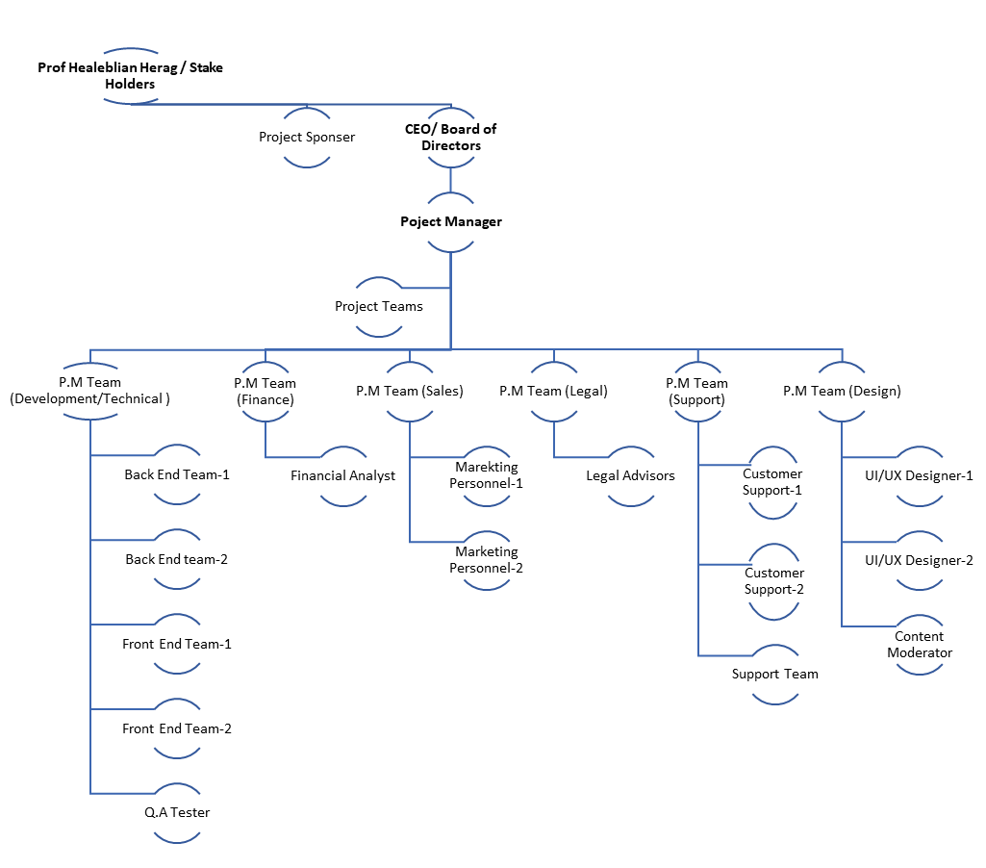
The organizational chart we've described seems to be designed to facilitate the efficient development and management of the mobile application, web platform, and related services for the University of Southern California (USC) project | Dorm Grader. Let's break down the reasons for this specific organizational structure based on the project's scope:

- University of Southern California (USC) |Dorm Grader: USC is at the top of the organizational chart because they are the project's client and ultimate authority. Professor Haleblian and Stake holders may represent the client's interests and vision for the project.

- Boards of Directors/ CEO: The ultimate authority and decision-makers within the project are the boards of directors/ CEO , responsible for making final determinations. The Project Manager serves as the reporting conduit to them, ensuring that relevant information is conveyed accurately. It is their duty to report to stakeholders and higher authorities, upholding transparency and accountability throughout the project's lifecycle.

- Project Manager: The project manager is crucial for overseeing the entire project, ensuring that it aligns with USC's goals, is completed within the specified time and budget, and that all components work together cohesively.

- PM Teams : The division of project management teams might be due to the specific department of the project. Each team can focus on specific aspects of the project (e.g. , Design, Technical, Sales etc), making management more efficient.ISE 515: Project Management (Team 4)

- Legal Advisors: Legal advisors are essential to ensure that the project complies with relevant laws and regulations, protecting both the project and USC.

- Frontend and Backend Developers: These teams are responsible for building the mobile application and web platform, respectively. Separating them can streamline development and ensure that each aspect is optimized for its specific platform.

- UI/UX Design: Placing the UI/UX Design under the Frontend Developer ensures a smooth collaboration between design and development teams, which is crucial for creating an attractive and user-friendly application.

- Content Moderator: This role is responsible for ensuring that user-generated content, like housing reviews and classified ads, meets USC's content guidelines.

- Financial Analysts: Financial analysts can help with revenue generation through advertisements and financial planning for the project.

- Marketing Personnel: They play a key role in promoting the application and web platform, attracting users, and generating revenue.

- QA Tester: QA testers ensure the quality and functionality of the application and web platform.

- Customer Support: Placing Customer Support under the Content Moderator suggests that they may work closely to address user inquiries and complaints related to content.

- Support Team: The encompassing scope of responsibilities extends across the pivotal domains of user registration, comprehensive data management, and the provision of user support services. In this professional capacity, the management and facilitation of user registration processes, meticulous handling of diverse data sets, and the seamless provision of user support are integral components, contributing to the overall efficacy and success of our operations.

The organizational chart seems designed to promote efficient communication and collaboration among different teams and roles, helping to ensure the successful development and operation of the mobile application, web platform, and related services according to USC's specific requirements and the project's scope. The project manager's role is central in coordinating all these teams to achieve the project's goal.

Project Schedule

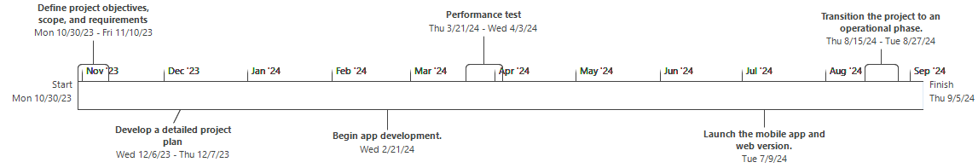

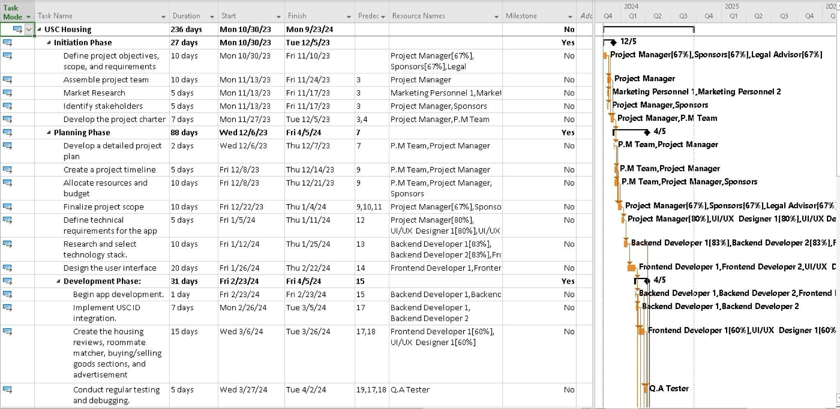

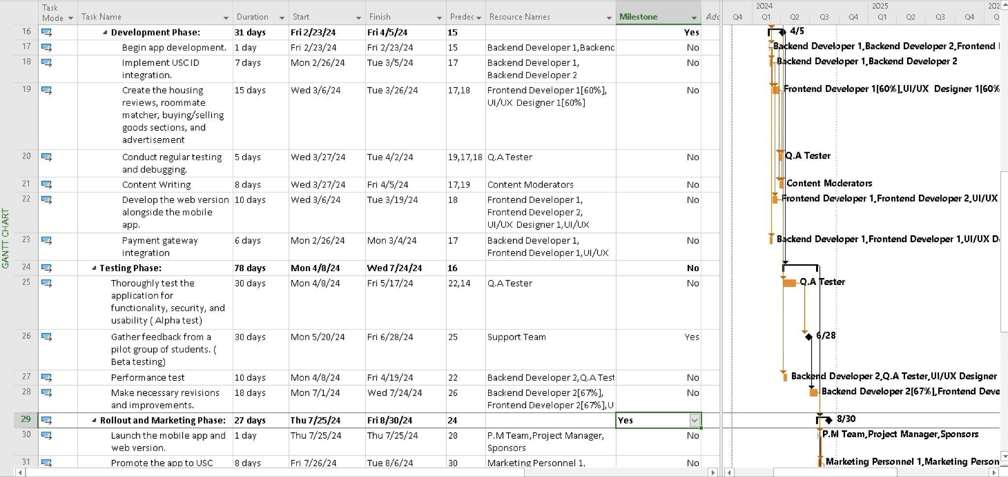
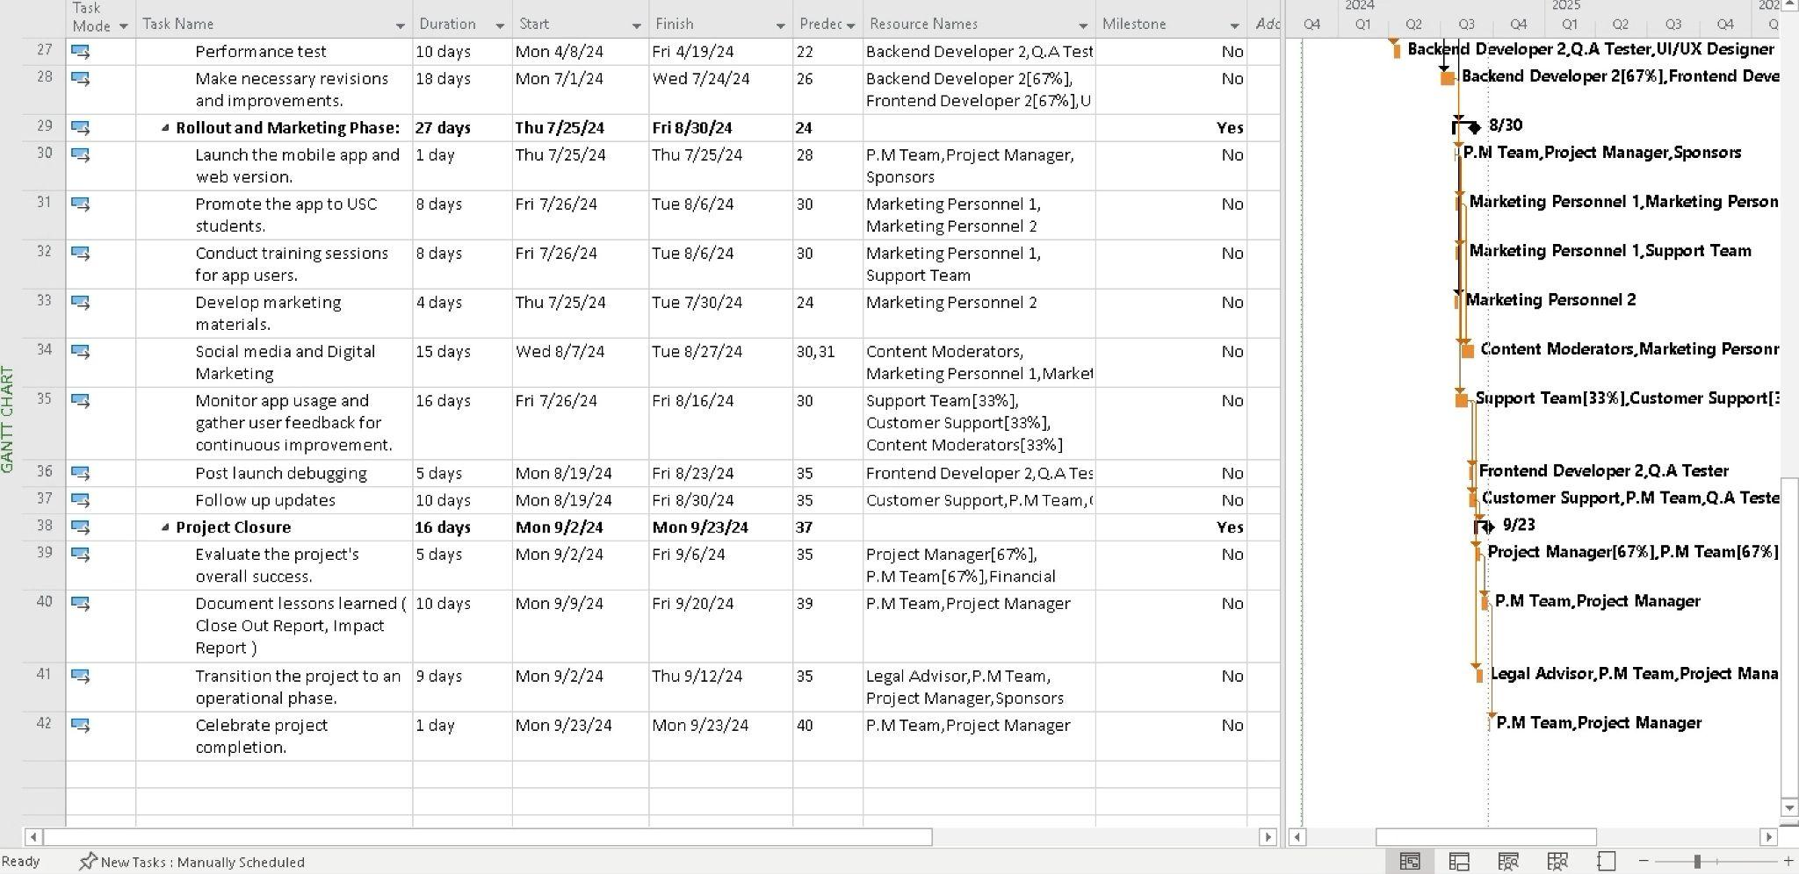

Critical Path tasks
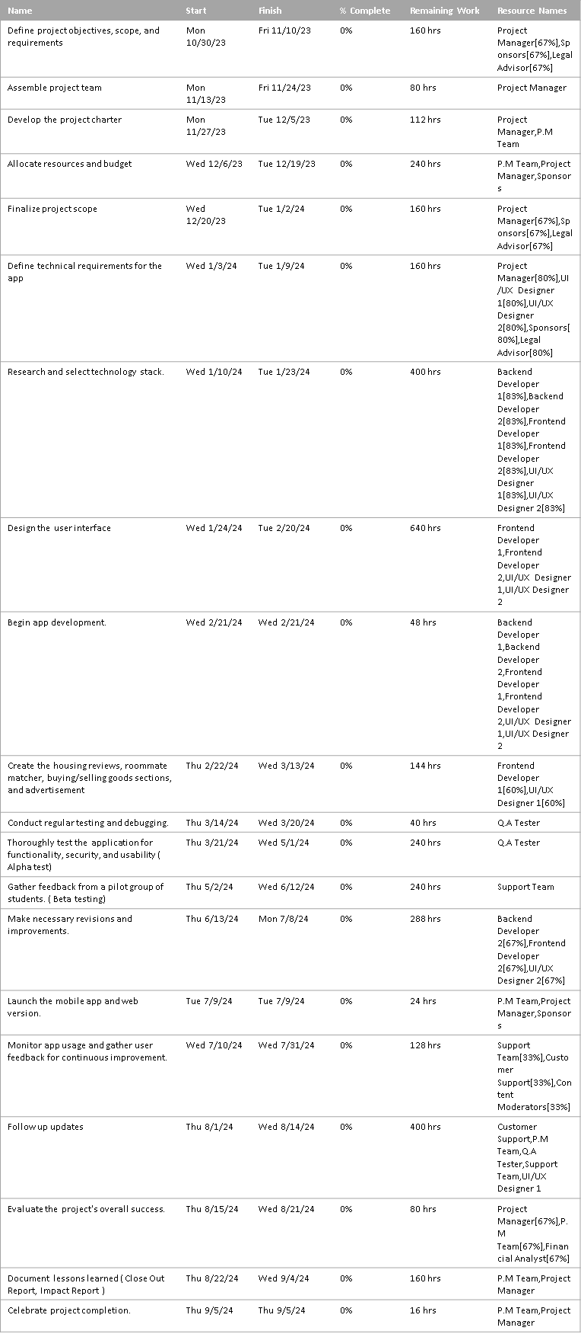

Risk Plan

Risk Probability and Impact

IMPACTS
 | Acceptable | 1- Tolerable | 2-  Unacceptable | 3- Intolerable
LOWRisk unlikely to occur | Low | Low-Med | Low-Med | Medium
MEDIUMRisk will likely occur | Low | Low-Med | Medium | High
HIGHRisk will occur | Low- Med | Medium | Medium | High

Risk name | Description | Likelihood | Impact | Mitigation | Contingency
Data Breach | Data breaches can result from intentional exploitation of security weaknesses or accidental exposure of sensitive data, either through malicious actions  or employee errors. | Medium | 3 | Employ high- security measures and regular audits. | In response to a data breach, contain, investigate, notify, restore, enhance security, and communicate effectively.
Biased Housing Reviews | Some students can be biased or influenced by the agents to submit dishonest reviews | High | 2 | Implement review verification systems and moderation. | Block the user after few warnings

User Adoption | Users might not accept the software. | Medium | 2 | Launch a comprehensive marketing campaign to attract users, offer incentives for early adoption, and continually improve the app's user experience to increase  engagement. | Change management encompasses user involvement in design and development, ongoing monitoring and feedback, and offering incentives for adoption.
Privacy and Security | Privacy and security breaches happen when sensitive information or systems are accessed or exposed without authorization. | High | 3 | Implement robust data encryption, enforce strict data access controls, conduct regular security audits, and stay up-to- date with data protection  laws. | Identify, contain, notify, investigate, mitigate, communicate, recover, and learn from the incident to minimize harm and prevent future breaches.
Competitive Landscape | There can be enough other apps and options | Medium | 3 | Conduct a thorough market analysis to identify unique selling points, continuously innovate to stay ahead of competitors, and build a strong brand and  community. | Real-time competitor analysis, adaptive tactics, innovation, and risk assessment to navigate competitive dynamics and seize opportunities uniquely.

Technical Challenges | The intricacy of the project's technical aspects could potentially lead to a postponement | Medium | 2 | Employ a dedicated technical team, conduct stress testing, and invest in reliable server infrastructure to minimize technical issues.  Implement regular software  updates and bug fixes. | Create transparent and well-defined technical requirements, such as operating systems, platforms, and cloud services, and appoint competent individuals to manage technical problems.
Improper Communication | Misunderstanding and lack of effective communication can take place in different teams | Medium | 1 | Make certain that the project team possesses the essential skills and knowledge required to tackle technical difficulties. | Establishing transparent communication standards for all parties involved, including team members, clients, and external vendors.
Legal and Compliance | Copyright infringement, data privacy breaches, contract disputes, and regulatory non-compliance | High | 3 | Consult legal experts to ensure compliance with data protection regulations, implement content moderation to prevent legal issues, and establish clear terms of  service for users. | Adhering to all applicable laws, regulations, and best practices, seeking legal counsel when needed, and implementing thorough compliance processes from the start.

Budget Overruns | Project budget runs out or less revenue generation than projected | Medium | 2 | Continuously monitor expenditures and put into action a strategy for cost reduction. | Create an exhaustive budget encompassing all anticipated costs, such as personnel salaries, software licenses, hardware, and any other project-  related expenses.
Financial Sustainability | No regular generation of revenues or app doesn't do well in the market | Medium | 2 | Diversify revenue streams, secure venture capital or funding sources, and maintain a lean operation to extend financial runway and ensure long-  term sustainability. | Target new customer segments or geographic markets to increase your customer base. License or franchise your software to third parties for a fee.

Project Budget, Implementation & Presentation

Project Budget
Develop a detailed project budget taking into consideration all costs

Budget Summary

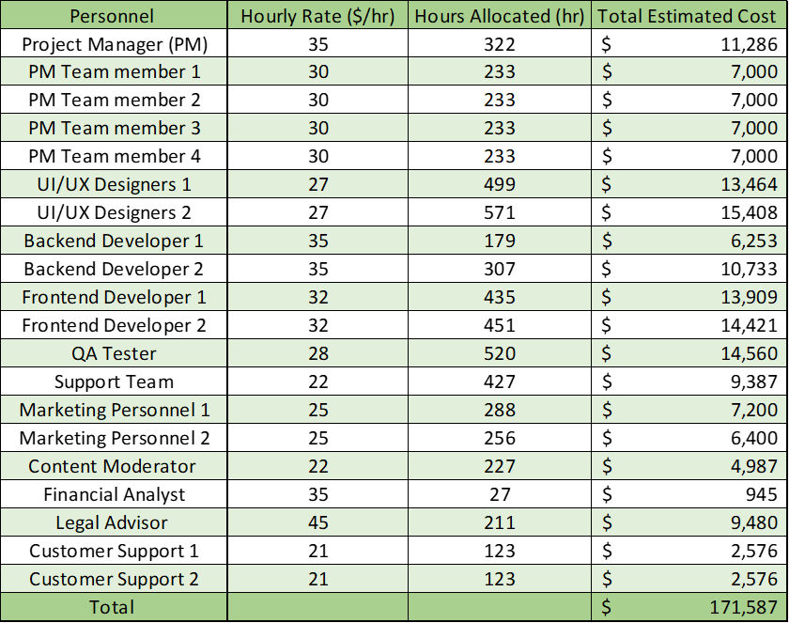

The USC Housing Mobile Application Project has an estimated total budget of approximately $237,000, encompassing all aspects of the project lifecycle. This budget allocation covers a range of categories including development, testing and quality assurance, operational costs, marketing and launch activities, personnel, and a contingency fund for unforeseen expenses. A significant portion of the budget is dedicated to development and personnel costs, reflecting the focus on high-quality software development and the crucial role of skilled team members. Additionally, the budget accounts for ongoing operational expenses and robust marketing efforts to ensure the app's successful deployment and adoption. Regular monitoring and adjustments are planned to ensure effective financial management throughout the project's progression.

Project Budget Breakdown

Development Costs
Software Licenses Costs for purchasing software tools required for development, such as Integrated Development Environments (IDEs), design tools, and database management software.
Backend Development Expenses related to server-side logic, database management, and API development. This typically includes salaries or fees for backend developers.
Frontend Development Costs for developing the user interface and user experience on mobile and web platforms. This covers frontend developers' salaries and any specific tools they might need.
UI/UX Design Fees for UI/UX designers who will design the application's interface and user experience. This may also include expenses for user testing and design software.

Testing and Quality Assurance (QA)
Software Testing Tools Investments in software and tools required for various types of testing, including unit, integration, and user acceptance testing.
QA Personnel Salaries or fees for QA testers responsible for ensuring the product is bug-free and functional. This also includes the cost of any external QA services if outsourced.

Operational Costs
Server Hosting Ongoing costs for cloud hosting services, which are necessary for hosting the backend and potentially the web platform.
Maintenance Regular maintenance costs post-launch to ensure the app remains functional and up-to-date.

Marketing and Launch
Marketing Materials Costs for creating graphics, promotional videos, and presentations. This includes both production costs and the fees for any external marketing agencies.
Advertising Budget for online and campus advertising campaigns to promote the app. This might include social media advertising, posters, and other promotional materials.
Launch Event Costs associated with organizing a launch event, which may include venue rental, catering, and equipment.

Personnel Costs
Project Management Salaries for project managers overseeing the project.
Development Team Combined salaries for the development team, including backend and frontend developers, as well as UI/UX designers.
Marketing Team Salaries for marketing personnel responsible for handling the app's promotion and outreach.
Customer Support Team Costs for staffing a customer support team post-launch to assist users.

Miscellaneous and Contingency
Miscellaneous An allocation for unforeseen expenses that do not fit into the other categories.
Contingency Fund A reserve fund to cover unexpected costs or budget overruns. Typically, this is a percentage of the total budget.

Considerations for Budget Planning
Accuracy and Realism The budget estimates should be as accurate as possible, based on realistic market rates and informed assumptions.
Flexibility The budget should allow some flexibility for unforeseen changes or challenges that may arise.
Monitoring and Control Regular monitoring of the budget against actual expenditures is crucial for maintaining financial control.
Stakeholder Review Regular budget reviews with stakeholders, particularly for significant expenditures or budget adjustments.
Team 4 Project Budget Link

Project Assumptions

### Comprehensive Assumptions in the USC Housing Mobile Application Project

#### Work Breakdown Structure (WBS) Assumptions
In the WBS, assumptions are related to project tasks, their execution, and dependencies:

WBS Phase/Task | Assumption Details
Initiation Phase | Defined objectives, scope, and requirements within scheduled time.
Team Assembly | Availability and timely assembly of skilled project team.
Market Research | Effective market analysis within the allocated time.
Stakeholder Identification | Early identification of key stakeholders for engagement.
Project Charter Development | Drafting a formal project directive within set timeline.
Planning Phase | Completion of comprehensive project planning.
Scope Finalization | Finalization of project scope without significant changes.
Technical Requirements Definition | Identification and definition of app's technical needs.
UI/UX Design | Design phase addressing user experience and interface requirements.
Development Phase | App development and feature creation adhering to schedules.
Testing Phase | Comprehensive testing of the app as planned.
Feedback Integration | Efficient incorporation of user feedback into app improvements.
Rollout and Marketing Phase | Successful launch, promotion, and user training.
Maintenance Phase | Ongoing and effective management of routine maintenance and user support.
Project Closure Phase | Meeting objectives and transitioning to operational phase.

#### Budget Assumptions
Specific assumptions related to the project's budget, including salary rates:

Role | Hourly Rate | Assumption Details
Project Manager (PM) | $35/hr | Moderate compensation for project oversight.
PM Team Members | $30/hr | Standard rates for project management support staff.
UI/UX Designers | $27/hr | Market rate for design roles.
Backend Developers | $35/hr | Industry standard for backend development.
Frontend Developers | $32/hr | Typical frontend development salaries.
QA Tester | $28/hr | Standard quality assurance personnel compensation.
Support Team Members | $22/hr | Entry-level rates for support roles.
Marketing Personnel | $25/hr | Industry standards for marketing roles.
Content Moderator | $22/hr | Focus on content quality and control.
Financial Analyst | $35/hr | Expertise in financial management and planning.
Legal Advisor | $45/hr | Specialized legal expertise.
Customer Support Reps | $21/hr | Industry standards for customer support roles.

#### Additional Key Project Assumptions
From various document sections, addressing different project facets:

1. **Resource Availability**: Skilled personnel and technical resources continuously available.
2. **Technological Feasibility**: Advanced, reliable, scalable technology stack and tools.
3. **Market Alignment**: App design and functionality align with university students' needs.
4. **Data Integrity**: Effective moderation systems for content quality control.
5. **Housing Information Accuracy**: Up-to-date and comprehensive housing data from collaborations.
6. **User Engagement Strategies**: Active strategies like gamification for student participation.
7. **Stakeholder Communication**: Regular engagement with stakeholders.
8. **Project Management Flexibility**: Dynamic scheduling and management for changes.
9. **Testing and Quality Assurance**: Comprehensive testing phases integrated into the development process.
10. **Operational Transition Planning**: Detailed plans for transitioning from development to maintenance.
11. **Success Metrics Evaluation**: Regular assessments against comprehensive success metrics.
12. **Scalability of Tech Infrastructure**: Infrastructure planning for growing user numbers and data.

These assumptions, spanning from WBS and budget planning to broader project management aspects, are integral to the project's strategy, technological choices, stakeholder management, and operational planning【56†source】【57†source】【67†source】.

Key Assumptions

Resource Availability and Team Capability
The assumption includes continuous availability of skilled personnel, including developers, designers, project managers, and marketing staff, along with necessary technical resources like software tools and server infrastructure. The team is expected to have expertise in contemporary mobile app development technologies and methodologies.

Technological Feasibility and Infrastructure
The technology stack and tools selected are presumed to be advanced, reliable, and capable of supporting both current needs and future expansions. Infrastructure planning includes considerations for high app performance, data security, and scalability to manage increased user traffic as the app grows in popularity. Amazon Web Services (AWS) for cloud hosting and server infrastructure, and development tools from Microsoft Azure and Atlassian Jira.

Market Research and Student Engagement
Detailed market research underpins the app's design and functionality, ensuring it aligns with the specific needs and preferences of university students. Engagement strategies such as gamification elements or tangible rewards are planned to motivate students to actively use and contribute to the app.

Data Integrity and Moderation
A sophisticated moderation system, including algorithms for detecting and flagging inappropriate or biased content, is in place to maintain the quality and integrity of user-generated content. Verification processes are also assumed to be implemented to ensure reviewers are actual students of the respective universities.Integration of IBM’s AI-driven moderation tools and Google's advanced analytics for data integrity monitoring.

Accurate Housing Information
Strong collaborations with housing providers, real estate databases, and university housing departments are assumed to ensure the app provides accurate, comprehensive, and up-to-date housing information. Regular updates and accuracy checks are planned to maintain the reliability of the information displayed on the app.Partnerships with Zillow for real estate data integration and collaboration with university housing departments for accurate listings.

User Feedback and Continuous Improvement
A proactive approach to collecting and analyzing user feedback through various channels, including in-app surveys, feedback forms, and direct user interactions. The project assumes an agile response mechanism to implement changes based on this feedback, aiming to enhance user experience and app functionality continuously. User feedback tools from Qualtrics and behavior analysis through Google Analytics.

Budget and Financial Management
The budget is meticulously planned, covering all project phases and tasks, with allocations for unforeseen expenses and budget overruns. Regular financial reviews are anticipated to track spending and adjust the budget as needed, ensuring financial control and transparency throughout the project. Financial planning and tracking through SAP’s software solutions.

Stakeholder Engagement and Communication
Active and ongoing engagement with all stakeholders, including the project team, university administration, students, and housing providers. Communication strategies include regular updates, feedback sessions, and promotional activities to ensure stakeholder alignment and support. Slack for internal stakeholder engagement and Mailchimp for external communications.

Schedule and Project Management
The project schedule is dynamic and allows for adjustments in response to unforeseen challenges or changes in project scope. Effective project management practices are assumed, incorporating risk management and contingency planning to address potential delays or obstacles. Project scheduling and management through Microsoft Project.

Testing Effectiveness and Quality Assurance
The project includes thorough and iterative testing phases, covering functionality, security, and user experience aspects. Quality assurance is integrated into the development process, enabling immediate resolution of issues and continuous product improvement.

Operational Transition and Maintenance
A detailed transition plan for moving from the development phase to operational maintenance is assumed. This includes strategies for ongoing user support, technical maintenance, and periodic updates to keep the app relevant and functioning optimally.

Project Success Metrics
Success metrics are comprehensive, evaluating the project based on user satisfaction, technical performance, adoption rates, and alignment with initial objectives. Regular assessments against these metrics ensure the project stays on track towards achieving its goals.

Student Engagement and Incentivization
The app's design and features are tailored to foster student engagement, with specific incentives for leaving reviews and contributing content. This includes implementing elements of gamification and potentially offering tangible rewards to encourage active participation.Incentives through partnerships with Starbucks and design materials using Adobe Creative Cloud.

Tech Infrastructure and Scalability
Significant investment in technical infrastructure is assumed, including a skilled development team, robust server infrastructure, and a focus on continuous maintenance and updates. Scalability is a key consideration, planning for the app's capacity to handle growing numbers of users and increased data loads. Cisco technologies for networking solutions and VMware for virtualization to ensure scalable infrastructure.

Budget Assumptions

Salary Assumptions
Project Manager (PM) is compensated at an hourly rate of $35/hr.
PM Team Member roles (1 through 4) each have an hourly rate of $30/hr.
UI/UX Designers (1 and 2) have an hourly rate of $27/hr.
Backend Developers (1 and 2) are compensated at $35/hr.
Frontend Developers (1 and 2) have an hourly rate of $32/hr.
QA Tester has an hourly rate of $28/hr.
Support Team members are paid $22/hr.
Marketing Personnel (1 and 2) have an hourly rate of $25/hr.
Content Moderator is compensated at $22/hr.
Financial Analyst has an hourly rate of $35/hr.
Legal Advisor is the highest-paid on an hourly basis at $45/hr, suggesting specialized, as-needed consultation.
Customer Support representatives (1 and 2) have an hourly rate of $21/hr.

Software and Hardware Costs Assumptions
Project management, design tools, customer support system, network security, and server costs are based on monthly subscription rates, with an estimated total software cost of $15,045.
Application software user licenses and database user licenses cost $600 and $200 per month, respectively, contributing to a total software estimated cost.
The hardware budget, including high-performance laptops, backup devices, and networking equipment, amounts to a total estimated cost of $23,000.

Office and Infrastructure Costs
The office space costs $4,500 per month, with a total estimated cost of $38,100 for the assumed project duration.
Utilities are expected to be around $500 per month, with the total estimated cost reaching $3,733.
Furniture and equipment carry an initial cost of $10,000 with a monthly cost of $1,000, amounting to $17,467 in total.
Business insurance costs are projected at $150 per month, totaling $1,120.

Organizational Change Management Plan
Introduction
The app's latest update involves integrating a Virtual Reality (VR) feature into the USC Housing Mobile App, enabling students to virtually explore off-campus housing options. To achieve this goal, the management plans to introduce specific roles like VI specialist, Data Analyst, and Community Manager. Additionally, there's a need to redefine current roles to encourage collaboration across functions. Implementing a more agile project management structure aims to enhance adaptability and speed.
The introduction of specialized roles like VI specialist, Data Analyst, and Community Manager, combined with the transition to Agile project management, offers substantial benefits. This change enhances collaboration and innovation, improves responsiveness to market and user needs, and increases productivity and efficiency. It also enables data-driven decision-making, elevates user experience, and assures higher product quality. Furthermore, this shift fosters a more flexible, adaptable organizational structure, boosts employee engagement and morale, and strengthens the company's competitive advantage, all while enhancing risk management through continuous feedback and iterative development.
SCOPE
Scope of Organizational Change

- Integration of New Roles:
VI specialist : Incorporation of a role focused on user experience design to enhance the usability and aesthetic appeal of projects.
Data Analyst : Introduction of a role responsible for analyzing data to drive decision-making and improve project outcomes.
Community Manager : Addition of a role dedicated to managing community engagement, user feedback, and public relations.

2. Redefinition of Existing Roles :
Existing roles in the project team will be evaluated and redefined to align with Agile methodologies and cross-functional collaboration.
This redefinition will involve adjustments in responsibilities, reporting structures, and collaboration methods.

3. Transition to Agile Project Management :
Implementing Agile methodologies across the project teams to enhance adaptability, responsiveness, and iterative development.
Agile training and the establishment of Agile practices like Scrum, depending on the project requirements.

4. Cross-Functional Team Formation :
Creating teams that blend different specialties (development, testing, design, data analysis) to foster innovation and streamline project execution.
Promoting a culture of collaboration and knowledge sharing among different functional areas.

5. Communication and Collaboration Tools :
Implementing and/or upgrading tools and platforms to facilitate effective communication and collaboration in line with Agile practices.
Ensuring that all teams have access to and are trained in the use of these tools.

6. Performance Metrics and KPIs :
Establishing new performance metrics and KPIs to measure the effectiveness of the Agile transformation and the integration of new roles.
These metrics will focus on team productivity, project delivery timelines, quality of outputs, and employee engagement and satisfaction.

7. Training and Support :
Comprehensive training programs for all team members on Agile methodologies and for individuals transitioning to new or redefined roles.
Ongoing support structures, such as mentorship programs and peer learning groups, to facilitate continuous development.

8. Cultural Alignment :
Ensuring that the changes align with the organization's core values and culture.
Initiating programs and activities that reinforce the desired organizational culture in the context of the new changes.

9. Feedback and Continuous Improvement :
Establishing mechanisms for regular feedback from team members regarding the change process.
Using this feedback for continuous improvement of the change implementation strategies.
Implementing ADKAR Model for Change Management

- Awareness:

- Communicate the need for new roles and restructuring.
- Explain the benefits of Agile methodology and cross-functional collaboration.
- Address employee concerns and create a sense of urgency.

- Desire:

- Highlight the advantages of role specialization and Agile practices.
- Involve team members in the process to foster ownership.
- Acknowledge and address resistance to change.

- Knowledge:

- Provide training specific to new roles and Agile methodologies.
- Use diverse learning materials and methods for effective knowledge transfer.
- Offer support systems, such as mentorship and peer learning.

- Ability:

- Facilitate hands-on experience in new roles and Agile practices.
- Promote team collaboration to enhance skill development.
- Establish an environment that supports experimentation and learning.

- Reinforcement:

- Recognize and reward adherence to new roles and Agile practices.
- Implement feedback loops to gauge success and areas for improvement.
- Ensure continuous improvement and adaptation of roles and processes.

Communications Plan for OCM
Objectives:
- Structured Updates: Establish a cadence for regular, structured communication updates through emails, newsletters, and team meetings.
- Feedback Channels: Open channels for feedback, such as surveys and open forums, to understand concerns and suggestions.
- Change Champions: Identify and empower change champions within teams to facilitate communication and encourage buy-in.
Key Messages
- Purpose: Enhancing user experience through VR integration and role restructuring for improved innovation and collaboration.
- Benefits: Improved responsiveness to user needs, increased productivity and efficiency, data-driven decision-making, and strengthened competitive advantage.
- Impact: Elevating product quality, fostering a flexible organizational structure, and enhancing employee engagement and morale.
- Process: Transitioning to Agile project management to enable adaptability, speed, and continuous improvement.

Target Audiences
1. Project Team Developers, designers, testers, project managers.
2. University Administration Including IT department, student affairs, housing services.
3. Students and Faculty The primary users of the application.
4. Other Stakeholders Potential partners, advertisers, external vendors.

Communication Channels
- Town Hall Meetings: Kick off the communication plan with an all-hands meeting to announce the changes, discuss objectives, and address initial concerns.
- Email Updates: Regular emails to stakeholders providing progress updates, key milestones, and highlighting success stories.
- Internal Intranet/Portal: Detailed information, FAQs, and resources accessible for all employees to reference at any time.
- Training Sessions/Workshops: Conduct training sessions for the new roles and Agile methodologies, ensuring understanding and alignment.
- One-on-One Meetings: Encourage managers to have individual discussions with team members to address specific concerns and gather feedback.
- Collaboration Tools (Slack, Teams, etc.): Establish dedicated channels for ongoing discussions, questions, and feedback from employees across departments.
- Surveys and Feedback Mechanisms: Periodic surveys and feedback forms to gauge understanding, concerns, and suggestions from employees.

Communication Activities
Communication type | Objective | Method | Frequency | People involved | Meet lead
Initial meeting | To discuss the new VR systems , roles of team, agile transformation | Face to face | once | - CEO  -Project Manager  - Sponsor  - Marketing Head  - Techteam Head  - Project lead  - Finance team Lead  - - Legal team lead | Project Manager
Initial Announcement | Immediate communication to announce the new change. | Email | once | - Project Manager  - Content Moderator | CEO
Managers Briefing | quip managers with comprehensive information and communication tools to cascade to their respective teams effectively. | Virtual Meet | Once biweekly | -Project Manager  - All department managers | Project Manager
Stakeholder Meetings | Briefing sessions with university administration and department heads. | Virtual Meet | once | - Project Manager  -Sponsor  -Project lead | Project Manager  USC Representatives
Meeting with Tech development team | Communication regarding the possible changes , form nw team dynamics by introduction of new members | Face to face | Weekly | - Project manager  - Tech Team Lead  - UX designers  - Frontend developers  - Backened Developers | Project Manager  Tech Team Lead
Meeting with finance team | Discussion on how to fund the new change. | Face to face | Weekly | - Finance team lead team  - Project Manager  - Sponsor  - Finance team | - Finance team lead team  - Project Manager
Meeting with Marketing team | Discussion on how to compete the other competitor, changes in the marketing campaign | Face to face | Weekly | - Marketing Manager  - Marketing team  - Project Manager | -Project Manager  - Marketing team
Progress Tracking and Reporting | Progress reports to high-level stakeholders  Real-time progress tracking available on the project portal. | Slack | Weekly | All teams | Project Manager
Closing Communication | Official announcement of the project completion with an overview of achievements, challenges faced, and lessons learned. | Virtual | Once | All teams and stakeholders | Project Manager  Sponsor

This comprehensive communication plan aims to maintain transparency, foster collaboration, and manage expectations effectively throughout the accelerated project timeline. Regular updates, clear messaging, and open channels for feedback are vital components of this plan.

Stakeholder Engagement Plan for OCM
Stakeholder Plan for OCM (Dorm Grader) Integration with Virtual Reality Feature
The latest update to the Dorm Grader (OCM) involves the integration of a Virtual Reality (VR) feature, allowing students to explore off-campus housing options virtually. This strategic move aims to enhance user experience, increase engagement, and stay ahead of the competition. The project also includes the introduction of new roles and a shift to Agile project management for improved collaboration and responsiveness.
Stakeholders
1. USC Board of Directors:
Objective: Ensure alignment with the overall strategic goals of USC.
Communication: Monthly progress reports and presentations highlighting the impact on student experience, innovation, and competitive advantage.
Engagement: Periodic meetings to address concerns and gather insights.
2. USC Students and Staff:
Objective: Enhance user experience and gather feedback.
Communication: Regular newsletters, in-app notifications, and town hall meetings.
Engagement: User testing sessions, surveys, and feedback forums.
3. USC IT Department:
Objective: Successfully integrate VR features and ensure system compatibility.
Communication: Weekly updates on technical progress, challenges, and resolutions.
Engagement: Collaborative workshops, technical briefings, and feedback sessions.
4. Project Development Team:
Objective: Efficiently execute the integration of VR feature and role restructuring.
Communication: Daily stand-up meetings, bi-weekly sprint reviews, and project documentation.
Engagement: Agile training, team-building activities, and continuous improvement sessions.
5. Marketing Team:
Objective: Effectively promote the new VR feature and highlight role changes.
Communication: Marketing strategy presentations, regular updates on promotional activities.
Engagement: Collaboration meetings with development and user feedback teams for aligning messaging.
6. Landlords in the Area:
Objective: Ensure seamless integration and cooperation.
Communication: Informational sessions, FAQs, and personal outreach.
Engagement: Platform demonstration and feedback sessions.
7. Advertised Businesses:
Objective: Align advertising strategies with the app's changes.
Communication: Updated marketing collateral, partnership meetings.
Engagement: Collaborative advertising campaigns, joint promotional events.
8. Potential Investors or Funders:
Objective: Showcase the app's increased competitiveness and potential returns.
Communication: Quarterly financial reports, project milestones updates.
Engagement: Investor presentations, Q&A sessions, and personalized updates.
9. User Feedback Community:
Objective: Gather continuous insights for iterative improvements.
Communication: Regular feedback surveys, in-app feedback prompts.
Engagement: Exclusive beta testing opportunities, feedback acknowledgment.
10. Competing Platforms
Objective: Stay informed about industry changes and maintain a competitive edge.
Communication: Regular market analysis reports, competitive feature updates.
Engagement: Attend industry conferences, participate in benchmarking studies.
11. Regulatory Authorities
Objective: Ensure compliance with relevant regulations.
Communication: Legal briefings, compliance reports.
Engagement: Periodic meetings to address any regulatory concerns.
12. Campus Safety and Security
Objective: Ensure the new features do not compromise safety.
Communication: Regular safety audits, security feature briefings.
Engagement: Collaborative sessions on emergency response planning.

This stakeholder plan aims to foster transparent communication, active engagement, and collaboration across all key stakeholders. By addressing the unique concerns and expectations of each group, the successful integration of the VR feature and organizational restructuring can be achieved, leading to a more competitive and innovative Dorm Grader.
The following is the Stakeholder Engagement Matrix for the OCM Plan
Desired level (“D”) of engagement for each stakeholder
Current level (“C”) of engagement for each stakeholder

Stakeholder | Unaware | Resistant | Neutral | Supportive | Leading
USC Board of Directors |  |  |  |  | C D
USC Students and Staff |  |  | C | D
USC IT Department |  |  |  | C D
Project Development Team |  |  |  | C D
Marketing Team |  |  | C | D
Landlords in the Area |  | C |  | D
Advertised Businesses |  |  | C | D
Potential Investors or Funders |  |  | C D
User Feedback Community | C |  | D
Competing Platforms | C |  |  |  | D
Regulatory Authorities |  |  | C | D
Campus Safety and Security |  |  | CD

Training and Development Plan for OCM
Training and Development Plan for Dorm Grader (OCM) Integration with Virtual Reality Feature
The training and development plan is designed to equip the team with the necessary skills and knowledge required for the successful integration of the Virtual Reality (VR) feature into the OCM. Additionally, it aims to facilitate the transition to Agile project management, enhance collaboration, and ensure that all team members are well-prepared for their new or modified roles.
1. VI Specialist, Data Analyst, and Community Manager Training
Objective: To ensure the newly introduced roles are well-understood and effectively carried out.
Activities:
External training sessions or workshops for UX design principles, data analysis tools, and community management strategies.
Internal cross-functional training sessions to foster collaboration and understanding of each role's contribution.
Mentorship programs pair experienced team members with those new to their roles.
2. Agile Project Management Training
Objective: Enable the team to adopt Agile methodologies for improved adaptability and speed in project management.
Activities:
External Agile training workshops for the entire project development team.
Internal hands-on workshops to apply Agile principles to ongoing projects.
Continuous coaching and feedback sessions to reinforce Agile practices.
3. Technical Training for IT Department:
Objective: Ensure the IT department is proficient in handling the technical aspects of VR integration and system compatibility.
Activities:
VR technology workshops and training sessions.
Cross-functional collaboration sessions between IT and development teams.
Continuous learning opportunities through online courses and certifications.
4. Marketing and Communication Training
Objective: Equip the marketing team with the skills to effectively communicate the changes and promote the new VR feature.
Activities:
Marketing strategy workshops focusing on the unique aspects of VR promotion.
Cross-departmental communication training to align messaging across teams.
Role-playing exercises to simulate different communication scenarios.
5. Collaborative Team-Building Activities:
Objective: Foster a collaborative and innovative team culture.
Activities:
Team-building workshops focusing on trust, communication, and problem-solving.
Interdepartmental collaboration events to strengthen relationships.
Regular team-building activities, such as offsite retreats and team lunches.
6. Platform Demonstration and Feedback Sessions:
Objective: Ensure landlords, advertised businesses, and potential investors are well-acquainted with the new features.
Activities:
Live demonstrations of the updated platform for stakeholders.
Q&A sessions to address concerns and gather feedback.
Informational sessions on the benefits of advertising on the enhanced platform.

7. Continuous Learning Opportunities:
Objective: Encourage a culture of continuous learning to adapt to industry changes.
Activities:
Subscriptions to relevant industry publications and online learning platforms.
Regular sharing sessions where team members present insights from their learning experiences.
Encouragement of attendance at industry conferences and workshops.

8. Safety and Security Training:
Objective: Ensure that safety and security considerations are integrated into the development process.
Activities:
Workshops on embedding safety features into the VR experience.
Collaboration sessions with campus safety and security teams.
Emergency response training for all team members.

9. Regular Progress Review and Feedback Sessions:
Objective: Monitor the effectiveness of the training and development plan and gather feedback for continuous improvement.
Activities:
Monthly progress review meetings with team leaders.
Anonymous feedback surveys to gauge the impact of training on job performance.
Continuous improvement workshops to address emerging needs.

This comprehensive training and development plan aims to ensure that all team members are equipped with the skills and knowledge needed to successfully implement the changes outlined in the OCM statement. By investing in continuous learning, cross-functional collaboration, and role-specific training, the team will be well-prepared to deliver a high-quality and innovative Dorm Grader.
Transition Plan (Idea 2)
Transition Plan for Dorm Grader (OCM) Integration with Virtual Reality Feature
The transition plan outlines the phased approach to implementing the Virtual Reality (VR) feature and the organizational changes specified in the OCM statement. The objective is to ensure a smooth and successful transition while minimizing disruptions to ongoing operations.
1. Initiation Phase:
Objective: Clearly communicate the upcoming changes and initiate the transition process.
Activities:
Hold a kickoff meeting to introduce the project team and its objectives.
Conduct an organization-wide communication campaign to inform stakeholders about the upcoming changes.
Establish a dedicated transition team responsible for overseeing the entire process.

2. Planning Phase:
Objective: Develop a detailed plan outlining timelines, responsibilities, and resources required for the transition.
Activities:
Conduct a thorough impact assessment to identify potential challenges and risks.
Develop a detailed project plan with specific milestones and deadlines.
Assign roles and responsibilities for team members involved in the transition.

3. Communication and Stakeholder Engagement:
Objective: Maintain transparent and consistent communication with all stakeholders throughout the transition.
Activities:
Establish a communication plan outlining regular updates, newsletters, and town hall meetings.
Engage with key stakeholders, including the USC Board of Directors, students, staff, landlords, and businesses.
Set up feedback mechanisms to address concerns and gather insights.

4. Training and Skill Development:
Objective: Ensure that team members are adequately trained and prepared for their new or modified roles.
Activities:
Implement the training and development plan outlined earlier.
Schedule training sessions well in advance of role transitions.
Monitor and assess the effectiveness of training programs through feedback mechanisms.

5. Agile Adoption and Project Management Transition:
Objective: Facilitate a smooth transition to Agile project management methodologies.
Activities:
Conduct Agile training sessions for the project development team.
Gradually implement Agile practices, starting with small, low-impact projects.
Establish Agile coaching and support systems for team members.

6. Technical Integration:
Objective: Ensure a seamless integration of the VR feature and address any technical challenges.
Activities:
Collaborate closely with the IT department to address technical requirements and compatibility.
Conduct thorough testing and debugging of the VR feature.
Implement the integration in phases to minimize disruptions.

7. Marketing and Advertising Rollout:
Objective: Effectively promote the new VR feature and updated platform to the target audience.
Activities:
Develop a comprehensive marketing strategy aligning with the app's changes.
Coordinate with the marketing team to roll out advertising campaigns and promotional events.
Monitor and analyze the effectiveness of marketing initiatives.

8. Collaboration and Team-Building:
Objective: Foster collaboration and a positive team culture to support the organizational changes.
Activities:
Facilitate team-building activities and workshops.
Encourage cross-functional collaboration through joint projects and initiatives.
Recognize and celebrate successes and achievements during the transition.

9. Continuous Monitoring and Feedback:
Objective: Continuously monitor progress, gather feedback, and make necessary adjustments.
Activities:
Regularly review project milestones and adjust timelines if needed.
Conduct periodic surveys and feedback sessions to gauge the impact of changes on stakeholders.
Establish a feedback loop for ongoing improvements.

10. Post-Transition Evaluation:
Objective: Evaluate the success of the transition and identify areas for further improvement.
Activities:
Conduct a comprehensive post-transition review with key stakeholders.
Document lessons learned and best practices for future reference.
Develop a plan for ongoing support and maintenance of the VR feature.
This transition plan provides a structured approach to implementing the Virtual Reality feature and organizational changes outlined in the OCM statement. By carefully managing each phase and engaging with stakeholders, the transition process will be efficient and result in a successful integration of the new features into the Dorm Grader.

Organizational Readiness Plan for OCM
The organization is not always ready for Introduction of new systems and new team members. Absolutely, transitioning from a waterfall methodology to an agile approach also requires careful planning and execution. Here's a step-by-step readiness plan to facilitate a smooth transition:
Surveys and Assessments
Organizational Readiness Surveys: Design surveys to assess employees' perceptions, attitudes, and preparedness for the upcoming change. Questions can focus on awareness, willingness to adapt, and confidence in leadership.
Culture and Climate Assessments: Evaluate the organizational culture and climate to gauge receptiveness to change. This includes factors such as openness to innovation, communication channels, and trust in leadership.
Educate and Build Awareness
Training and Workshops: Conduct training sessions to familiarize employees with agile principles, values, and methodologies.
Communication Strategy: Develop a robust communication plan to ensure everyone understands the rationale behind the shift and its benefits.
Change Readiness Assessments
Change Readiness Assessments: Utilize validated change readiness models or assessments that provide a structured approach to evaluating various readiness dimensions. These models often include criteria such as leadership alignment, resource readiness, and employee commitment.
Create a Cross-Functional Team
Formation of Agile Champions: Establish a cross-functional team of agile experts or champions to guide the transition and advocate for agile principles.
Pilot Programs and Test Cases
Pilots and Test Cases: Conduct small-scale trials or pilot programs to assess readiness before full implementation. Evaluate feedback, challenges faced, and the success of these initiatives.
Risk and Issue Tracking
Risk Assessments: Track risks and issues associated with the change process. An increase or decrease in the number of risks identified or resolved can indicate shifts in readiness levels.

Employee Readiness and Training Metrics
Training Metrics: Measure participation rates, completion rates, and post-training assessments to evaluate the effectiveness of readiness-building training programs.
Pre- and Post-Change Assessments
Before and After Comparisons: Conduct assessments before and after the change implementation to compare readiness levels, attitudes, and performance metrics, highlighting shifts and improvements.
Provide Ongoing Support and Training
Continuous Support: Offer ongoing coaching, mentoring, and support to teams and individuals adapting to the agile methodology.
Regular Training: Conduct periodic training sessions to reinforce agile principles and practices.

Metrix and Measure for OCM
Metrics and Measures for Dorm Grader (OCM) Integration with Virtual Reality Feature
1. Adoption Metrics:
Objective: Measure the rate at which users are adopting and utilizing the VR feature.
Metrics:
Number of downloads and installations of the updated OCM app.
Percentage increase in daily active users engaging with the VR feature.
User engagement metrics within the VR environment (time spent, interactions).

2. User Experience Metrics:
Objective: Assess the impact of the VR feature on overall user satisfaction and experience.
Metrics:
User satisfaction surveys before and after the VR feature integration.
Average rating and reviews on app stores specifically related to the VR experience.
Time spent on the app per session and session frequency.

3. Technical Performance Metrics:
Objective: Evaluate the technical performance and reliability of the app with the VR feature.
Metrics:
App loading times, especially when accessing VR content.
A number of technical issues were reported and resolved.
Compatibility metrics across various devices and operating systems.

4. Agile Project Management Metrics:
Objective: Measure the effectiveness of the transition to Agile methodologies.
Metrics:
Velocity and sprint burndown charts to assess team productivity.
Time-to-market for feature releases compared to pre-Agile timelines.
A number of successful iterations and improvements are based on feedback.

5. Training Effectiveness Metrics:
Objective: Evaluate the success of the training and development plan.
Metrics:
Competency assessments for team members in new roles.
Training completion rates.
Frequency of skill application in day-to-day tasks.

6. Marketing and Advertising Metrics:
Objective: Gauge the success of promotional activities for the VR feature.
Metrics:
Click-through rates and conversions from marketing campaigns.
Social media engagement and mentions related to the VR feature.
Number of new users attributed to marketing efforts.

7. Collaboration and Team-Building Metrics:
Objective: Measure the impact of team-building activities on collaboration and culture.
Metrics:
Employee satisfaction surveys regarding collaboration and team dynamics.
Number of cross-functional initiatives or projects.
Employee retention rates during and post-transition.

8. Financial Metrics:
Objective: Evaluate the financial impact of the OCM updates and VR features.
Metrics:
Return on investment (ROI) based on increased user engagement and potential revenue from VR-related features.
Cost savings or efficiency gains attributed to Agile methodologies.
Revenue growth attributed to marketing initiatives.

9. Regulatory Compliance Metrics:
Objective: Ensure adherence to relevant regulations and standards.
Metrics:
Regular audits and assessments of compliance.
A number of reported or identified compliance issues and resolutions.
Documentation of regulatory approvals or certifications obtained.

10. Safety and Security Metrics:
Objective: Assess the effectiveness of safety and security features in the VR environment.
Metrics:
Incident reports related to safety or security concerns.
User feedback on perceived safety within the VR feature.
Regular security audits and updates to address emerging risks.

11. Continuous Improvement Metrics:
Objective: Measure the success of ongoing improvement efforts.
Metrics:
A number of identified improvements based on user feedback.
Time is taken to implement and deploy improvements.
Percentage increase in overall satisfaction over time.
These metrics and measures provide a comprehensive framework for evaluating the success of the OCM integration with the Virtual Reality feature. Regular monitoring and analysis of these metrics will enable the project team to make data-driven decisions, identify areas for improvement, and ensure the continued success of the Dorm Grader.

Project Change Controls

Scope
The scope of project change controls includes the changes that we would have to make in order to incorporate a change request in the scope of the project. The changes span from across various departments and might include a little bit of change in the process, but not necessarily. In our case, we have considered an example of change required to include a new loyalty program system. Since most of our competitors are selling the same platform with almost the same scope, we plan to differentiate ourselves by adding a feature that would create more loyal customers.
Highlights of the change
- Include a system that promotes user loyalty.
- Reward users with badges for each review.
- Display and make it more visible whenever a user sees their profile.

Approach To Change Request
The proposal for this change originates from a collaborative decision between the Board of Directors and the Marketing Department. This decision is based on research indicating the effectiveness of loyalty systems in increasing user engagement. The Board has also undertaken a competitive landscape analysis to carve out a unique selling proposition (USP) that sets our product apart from competitors.
The change request will be formalized and conveyed to the Technology Team upon approval. This team, comprising developers and system architects, will be responsible for actualizing the new feature within the application.
1. Assessment and Documentation
First, gather detailed information about the requested scope change. This involves discussing with the Board to understand their objectives and expectations. Document the change request formally and evaluate its impact on the project's objectives, deliverables, and success criteria.
2. Impact Analysis
Conduct an impact analysis on the current project plan, identifying how the new sub-section will affect the Work Breakdown Structure (WBS), schedule, budget, and resources.
3. Stakeholder Consultation
Engage with stakeholders, including the project team, customers, and end-users, to discuss the proposed changes and gather feedback.
4. WBS Update
Integrate new tasks and activities into the WBS specific to the development of the transportation/carpooling/parking sub-section. Redefine work packages and assign new roles and responsibilities as needed.
5. Schedule Adjustments
Revisit the project schedule to identify where new tasks can be inserted, considering dependencies and milestones. Determine if the timeline can accommodate these changes or if an extension is needed. Prioritize tasks based on the revised scope.
6. Budget Revision
Estimate the additional costs associated with the scope change, including new resource requirements, technology needs, and potential risks. Update the budget to reflect these costs and justify the changes based on the anticipated return on investment or strategic value.
7. Approval Process
Present the change request, along with the impact analysis, updated WBS, revised schedule, and budget to the Board for approval. Incorporate any feedback and finalize the documentation before proceeding.
8. Communication Plan
Develop a communication plan to inform all project stakeholders of the approved changes and how they affect the project.
9. Implementation and Monitoring
Implement the changes once approved and continuously monitor their impact on the project, adjusting the project management plan as necessary.
10. Risk Reassessment
Update the risk management plan to include any new risks introduced by the change in scope and define appropriate mitigation strategies.

Change Request Form
Project Name | USC Housing Mobile Application Project
Requested By | Marketing team
Request No | 00001 | Name Of Request |  | Loyalty Program feature
Change Description | Add a new Loyalty program with the following features.  - Include a system that promotes user loyalty.  - Reward users with badges for each review.  - Display and make it more visible whenever a user sees their profile.
Change Reason | This loyalty program will promote user engagement and a sense of reward among users for each review. It will help our company stand out in terms of competition among other entrants and incumbents. Attached is the competitive landscape analysis of this change request form.
Impact Of Change | This change will primarily impact the development and customer support teams. The marketing team would help promote the feature and analyze the effect of the loyalty system.
Proposed Action | Development team to lay out the Frontend for the program and get it approved by the UX team.  Testers can evaluate the SOLID architecture for the backend and ensure a sustainable code.
Status | In Review | Approved |  |  | Rejected
Status |  | ✅
Approval Date | Apr 25, 2024
Approved By | Board of Directors

Justification for Changes
The changes to the WBS, schedule, and budget are necessary to ensure that the project remains aligned with the updated strategic goals post-change.
Adapting the project plan for the new sub-section ensures that the project continues to meet stakeholder expectations and delivers added value.
The systematic approach to managing scope change minimizes disruption, ensures effective use of resources, and maintains project viability.

Impact on Budget
Development Costs:
Additional expenses for the development of the loyalty program system, including programming and system integration. Potential need for specialized software or tools to create and manage the loyalty program effectively.
Testing and Quality Assurance:
Increased costs for testing the new feature, ensuring it functions seamlessly with existing systems. Possible expenses for user testing to refine the feature based on real-world feedback.
Human Resources:
Salaries for additional manpower, such as developers, UX/UI designers, and QA testers, who will work on the new feature. Training costs for existing staff to manage or operate the new loyalty system.
Marketing and Promotion:
Budget for marketing campaigns to promote the new loyalty program to existing and potential users. Costs for creating promotional materials, including digital ads, tutorials, or informational content about the new feature.
Overall Financial Planning:
Revision of the overall project budget to accommodate these additional costs. Justification for increased expenditure based on expected returns, such as enhanced user engagement and competitive advantage.

Impact on Work Breakdown Structure (WBS)
Integration of New Tasks:
Addition of tasks related to the design, development, and implementation of the loyalty program. Sub-tasks for testing, user feedback collection, and refinement of the feature.
Reassignment of Responsibilities:
Assigning new roles and responsibilities to team members to cover the development of the loyalty program. Possible creation of a sub-team focused exclusively on the loyalty program feature.
Adjustment of Dependencies:
Analyzing and updating task dependencies to reflect how the new feature affects the overall project workflow. Ensuring that the integration of the loyalty system aligns with existing project phases and tasks.

Impact on Project Scope
Expansion of Functionalities:
The project scope expands to include the development and integration of a loyalty program. This addition enhances the application's capabilities, offering more value to users.
User Experience Enhancement:
A direct impact on the user experience, potentially increasing user engagement and satisfaction. The loyalty program is expected to contribute to higher user retention rates.
Competitive Differentiation:

The new feature serves as a unique selling proposition, differentiating the product in the market. Aligning with market trends and user expectations to stay competitive and relevant.

Changes to Plan

Revised WBS
Since the change was approved on April 25th, the work is scheduled on May 3, 2023. However, since the OCM is also shifting toward the Agile methodology, we will not disrupt the existing development but will work on the development parallelly. Program managers have neatly estimated the feature to include fair engineering hours and that the development of the feature would start on May 3, 2024 and end on Jun 1, 2024. Fortunately, since this time we are still in the build and testing phase, we do not need to tamper with the critical path, and we expect the changes to be in production before roll out.
Post that, it will again pass on to the testers and UX and finally be included in the production before rollout.
For convenience, we will add the WBS snippet of previous tasks and the current revision as follows. Note that the added contents in the WBS are included in pink color, and the green color represents the continuation of a previous plan.
4.2 | Testing | Gather feedback from a pilot group of students (Beta testing) | Collect and analyze user feedback | Thu 5/2/24 | Wed 6/12/24 | Yes
4.3 | Testing | Incorporate feedback and make necessary changes | Update the app based on user feedback | Thu 3/21/24 | Wed 4/3/24 | No
3.7 | Development | Incorporate the new loyalty program feature | Development works on the new loyalty program. | Fri  5/3/24 | Wed  5/15/24 | No
4.3.1 | Testing | Test the new loyalty program feature | The dev team follows tester recommendations on changes and bug fixes. | Fri  5/10/24 | Fri  5/24/24 | No
4.3.2 | UX | Test the usability and experience of the new feature | The dev team works with UX closely to incorporate changes. | Fri  5/17/24 | Fri  5/31/24 | No
5.1 | Rollout and Marketing Phase | Launch mobile and web versions. | Release the application to the public. | Tue 7/9/24 | Tue 7/9/24 | Yes

Revised Budget
The engineering hours estimated for this project are calculated as follows.
Development: 9 days
Testing: 11 days
UX/UI: 11days

Personnel | Hourly Rate ($/hr) | Hours Allocated (hr) | Revised Allocated (hr) | Revised Cost
Project Manager (PM) | 35 | 322 | 322 | $ 11,286
PM Team Member 1 | 30 | 233 | 233 | $ 7,000
PM Team Member 2 | 30 | 233 | 233 | $ 7,000
PM Team Member 3 | 30 | 233 | 233 | $ 7,000
PM Team Member 4 | 30 | 233 | 233 | $ 7,000
UI/UX Designers 1 | 25 | 499 | 543 | $ 13,575
UI/UX Designers 2 | 25 | 571 | 615 | $ 15,375
Backend Developer 1 | 30 | 179 | 197 | $ 5,910
Backend Developer 2 | 30 | 307 | 325 | $ 9,750
Frontend Developer 1 | 30 | 435 | 453 | $ 13,590
Frontend Developer 2 | 30 | 451 | 469 | $ 14,070
QA Tester | 25 | 520 | 608 | $ 15,200
Support Team | 19 | 427 | 427 | $ 8,107
Marketing Personnel 1 | 22 | 288 | 288 | $ 6,336
Marketing Personnel 2 | 22 | 256 | 256 | $ 5,632
Content Moderator | 19 | 227 |  | $ 4,307
Financial Analyst | 30 | 27 |  | $ 810
Legal Advisor | 40 | 211 |  | $ 8,426
Customer Support 1 | 19 | 123 |  | $ 2,331
Customer Support 2 | 19 | 123 |  | $ 2,331
Total |  |  |  | $ 165,036

References
“How to Develop a Risk Assessment Matrix For Business Success.” 2021. SteveBizBlog. https//stevebizblog.com/how-to-develop-a-risk-matrix/.

